CS-340 Module Seven Project Two
Marielys Abraham Reyes
Southern New Hampshire University
CS-340 Client/Server Development
Tenario Powell
October 18, 2026

CS 340 README Template
About the Project/Project Title
For Project Two, I created the Grazioso Salvare Rescue Dashboard using the animal shelter database we have been working with throughout CS 340. The goal was to make the Austin Animal Center records easier to explore, especially when looking for dogs that match the sample criteria for different rescue roles. Instead of searching through the entire collection manually, someone can choose a rescue category and see the matching animals, a breed chart, and a map in one place.
The dashboard is a screening tool, not a way to decide whether a dog is actually trained for rescue work. It simply helps organize the available shelter information into a more useful starting point.
Motivation
What interested me most about this project was finally seeing the database work turn into something interactive. Earlier assignments focused on MongoDB commands and the CRUD module, but this one connected those pieces to an interface that another person could actually use. I liked being able to see the results change immediately when I selected a different rescue category.
I also wanted the dashboard to be easy to understand without a lot of instructions. The radio buttons, table, chart, and map each have a purpose, so the user can explore the same information in different ways.
Getting Started
I reused my AnimalShelter class from the earlier module and imported it from CRUD_Python_Module.py. The class connects Python to the aac database and animals’ collection through PyMongo. The dashboard calls its read() method with MongoDB queries based on the rescue category selected.
Water Rescue, Mountain or Wilderness Rescue, and Disaster or Individual Tracking each use breed, sex, and age conditions from the project scenario. Reset returns the unfiltered records. I converted the results into a Pandas DataFrame and removed MongoDB's _id field before sending records to the Dash table, since ObjectId values cannot be displayed directly in that component.
Installation
I developed the project in Codio with Jupyter Notebook. The main tools were Python, MongoDB, PyMongo, Pandas, Dash/JupyterDash, Plotly Express, and Dash Leaflet. MongoDB stores animal records, Pandas organizes the query results, Dash handles the interface and callbacks, Plotly makes the pie chart, and Dash Leaflet displays the map.
To set up a compatible environment, install the packages needed by the notebook, for example:
pip install pymongo pandas numpy matplotlib dash jupyter-dash dash-leaflet plotly
MongoDB must be running with the aac database and animals’ collection already imported. Configure the database account for the environment; passwords should not be included in a public repository.
Usage
Keep ProjectTwoDashboard.ipynb, CRUD_Python_Module.py, and Grazioso Salvare Logo.png in the same working folder. Open the notebook, confirm that the database connection and logo filename match the environment, and run the notebook cell. Then open the URL printed by the Dash server.
The table supports sorting, filtering, pagination, and row selection. Selecting a rescue category updates the table and breed pie chart. The map shows a marker for the first filtered record with valid coordinates. Reset restores the complete dataset. The chart for Reset is more crowded because it includes so many breeds.
Code Example
This is a simplified example of how I connect the CRUD module and request records for a dashboard filter:
from CRUD_Python_Module import AnimalShelter

shelter = AnimalShelter(username, password)

query = {
"animal_type": "Dog",
"breed": "Labrador Retriever Mix"
}

matching_animals = shelter.read(query)

print(len(matching_animals))
The actual dashboard uses more conditions for each category and passes the results to its interactive components.
Tests
I tested the filters one at a time instead of assuming the whole dashboard was finished as soon as it loaded. Water Rescue returned Labrador Retriever Mix dogs in the records I tested. Mountain or Wilderness Rescue returned five dogs from four breeds, while Disaster or Individual Tracking returned four dogs across three breeds. Reset brought back cats and dogs from the full collection.
The biggest challenge was the map. At first the table and pie chart worked, but the map area stayed blank. I checked the callback and the coordinates and eventually corrected the page layout by giving the chart and map separate widths. After that, the map displayed next to the pie chart. That experience taught me to look at the layout as well as the Python logic when something is missing from a dashboard.
Screenshots
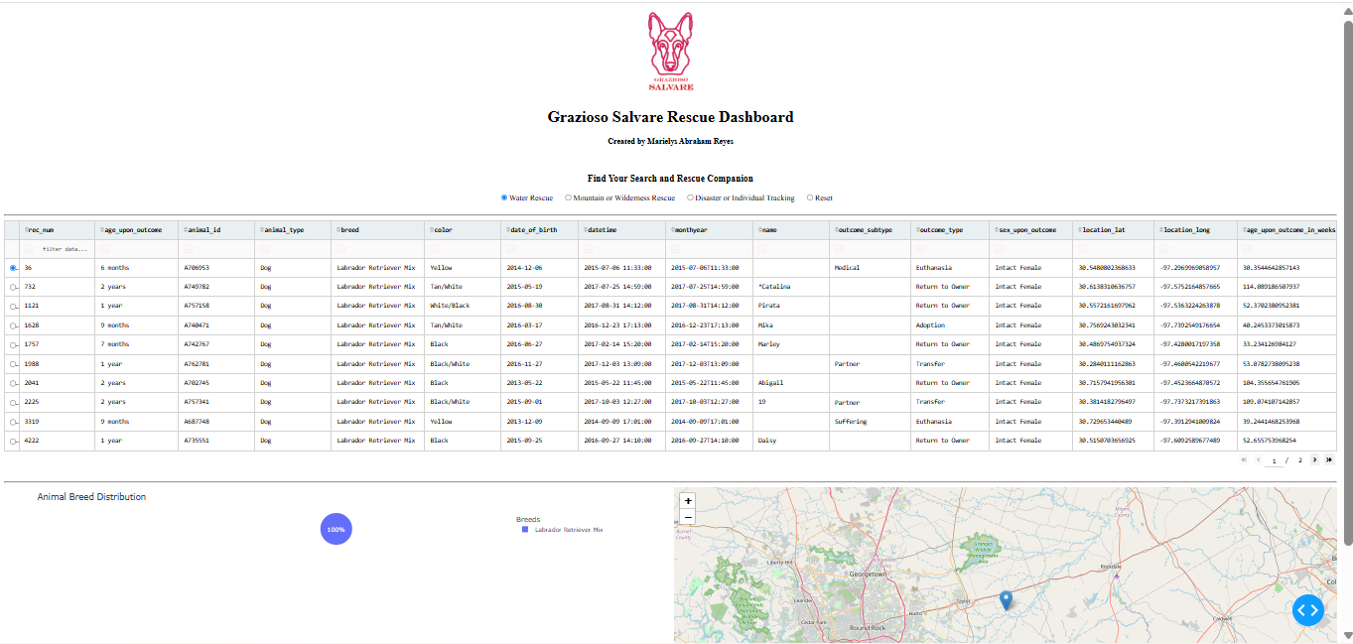
Figure 1. Water Rescue Filter
The Water Rescue selection shows matching Labrador Retriever Mix records, a breed chart, and a map marker.
Figure 2. Mountain or Wilderness Rescue Filter
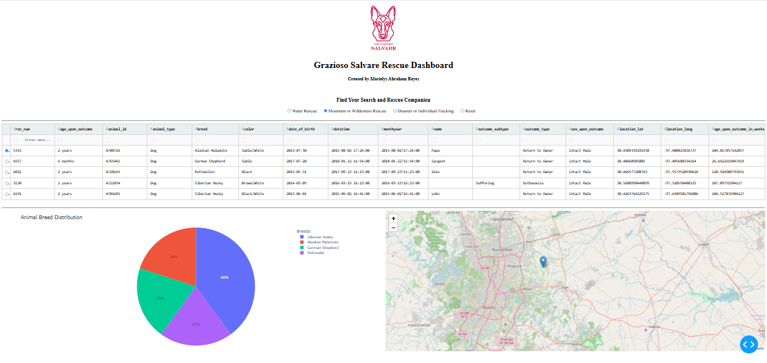
The Mountain or Wilderness Rescue selection shows five matching records and the distribution across four breeds.
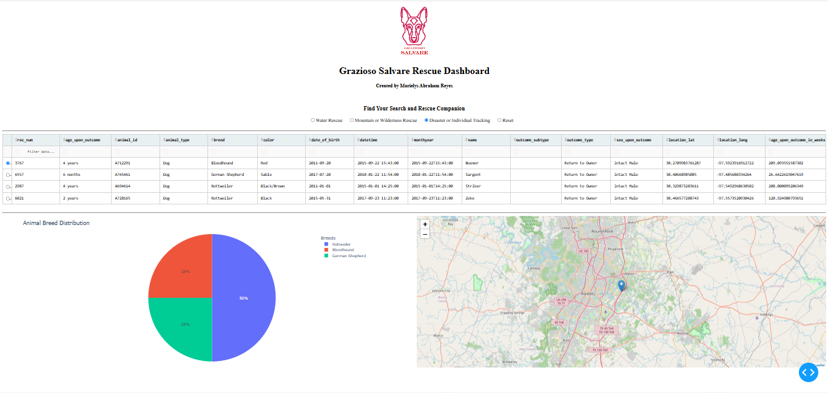
Figure 3. Disaster or Individual Tracking Filter
The Disaster or Individual Tracking selection shows four matching dogs, including Bloodhound, German Shepherd, and Rottweiler.
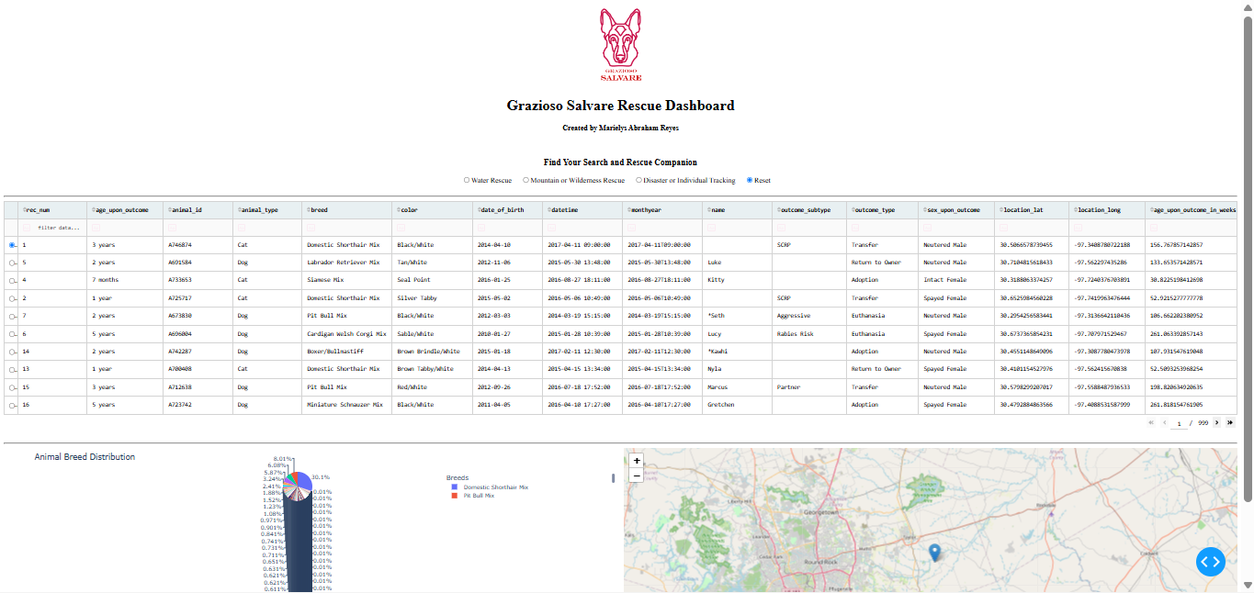
Figure 4. Reset Filter
Reset brings back the full shelter data. The breed chart is crowded because the dataset contains many breeds.
Contact
Marielys Abraham Reyes

